Strutture NON alberghiere: [https://forms.office.com/e/WLhmEicyFk](https://eur04.safelinks.protection.outlook.com/?url=https%3A%2F%2Fforms.office.com%2Fe%2FWLhmEicyFk&data=05%7C02%7Csisp%40ats-milano.it%7C8f4a32336dc2428e66c008dda73c684b%7Cdecf92f6527a40bf9345ba807fa42fab%7C0%7C0%7C638850600089550490%7CUnknown%7CTWFpbGZsb3d8eyJFbXB0eU1hcGkiOnRydWUsIlYiOiIwLjAuMDAwMCIsIlAiOiJXaW4zMiIsIkFOIjoiTWFpbCIsIldUIjoyfQ%3D%3D%7C0%7C%7C%7C&sdata=i0%2F%2BHN6Rm%2BAUMl%2FbAau87HLxMF7VpxKJOBupg4Qi7JQ%3D&reserved=0)

QR code strutture NON alberghiere:

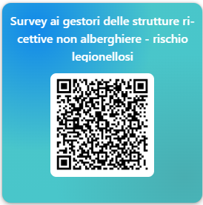

Link Infografica Legionella:

[Infografica Legionella - blu.pdf](https://www.ats-milano.it/sites/default/files/2024-09/Infografica%20Legionella%20-%20blu.pdf)